Week 1 Exercises: Introduction to React Native
Learning Objectives
After completing this exercise, you should be able to:
- Explain different approaches to mobile application development
- Describe how React Native works at a conceptual level
- Use basic React Native core components
- Create a simple user interface in Expo Snack
- Apply styling with StyleSheet
- Reflect on your own use of AI-assisted development tools

Part 1: Mobile Application Development Fundamentals
Imagine that you have been asked to build a mobile application for both Android and iOS devices.
1. Development Approaches
Explain the following approaches to mobile application development and provide at least one real-world example of each:
- Native mobile development
- Cross-platform development
- Web-based development
For each approach:
- Which programming languages are commonly used?
- Which tools or frameworks are typically used?
- Give one example application or technology stack.
2. Comparing Mobile Technologies
Discuss the following:
- What advantages do native mobile applications have compared to web applications?
- What advantages might web applications have compared to native applications?
- In which category does React Native belong?
- Why has React Native become popular among developers and companies?
3. React Native Architecture
Answer the following questions briefly:
- What role does JavaScript play in React Native applications?
- How does React Native differ from React for the web?
- What happens behind the scenes when a React Native Text component is rendered on Android or iOS?
- How does React Native enable one codebase to work on multiple mobile platforms?
Recommended answer length: approximately 1page.

Part 1: Mobile Application Development Fundamentals
1. Development Approaches
Answer:
Native mobile development built separately for each OS (Kotlin/Java for Android, Swift for iOS). Example: WhatsApp’s native builds, or any pure Swift app.
Cross-platform is one codebase for both (React Native, Flutter). Example: Instagram uses React Native in parts.
Web-based development means the app runs in a browser or a wrapper (Html/CSS/Js, PWAs). Examples Twitter’s PWA.
2. Comparing Mobile Technologies
Native apps generally have advantages in performance, full access to device hardware (camera, GPS, sensors, push notifications), smoother UI and offline use. Web apps have their own advantages like no installation needed, updates go live instantly without waiting for app-store approval, they’re cheaper to build once for everyone, and they can be opened on any device with a browser.
React Native belongs to the cross-platform category. It has become popular because a single codebase serves both iOS and Android (saving time and money), it uses JavaScript and React so there is already a huge pool of developers who can use it, it offers fast development with hot reload, and it renders real native UI components so performance stays close to native.
3. React Native Architecture
- JavaScript holds the app’s logic and describes the UI. It runs on JavaScript engine such as Hermes, and React Native passes those instructions to the native side of the platform.
- React for the web renders to HTML elements in the browser DOM like div and span, while React Native has no DOM or HTML, so it renders to real native components and uses elements like View and Text instead.
- When a Text component is rendered, React Native maps it to the platform’s own native text widget like a TextView on Android and the equivalent native text view on iOS, so what appears on screen is a genuine native element, not a web one.
- One codebase works on multiple platforms because we write shared React/JavaScript code, and React Native translates our components into each platform’s native equivalents at runtime. When needed, small platform-specific differences can be handled with the Platform module.

Part 2: Building a React Native UI
Create a simple React Native user interface for a small mobile application.
Possible ideas include:
- Weather application
- News reader
- Currency converter
- Fitness tracker
- Recipe app
- Event browser
- Movie information app
Choose any theme that interests you.
Requirements
Your UI must include:
- View
- Text
And at least three additional React Native core components, such as:
- Image
- TextInput
- Button
- ScrollView
- FlatList
- Pressable
- Switch
- ActivityIndicator
You can find component documentation at:
React Native Documentation
Important
This week focuses on user interface construction.
No actual functionality, state management, networking, or API calls are required.
Create a realistic-looking static UI mockup.
Reflection
For each component you use (other than View and Text), briefly explain:
- What the component does
- Where it might be used in a real mobile application

Part 2: Building a React Native UI
Answer:
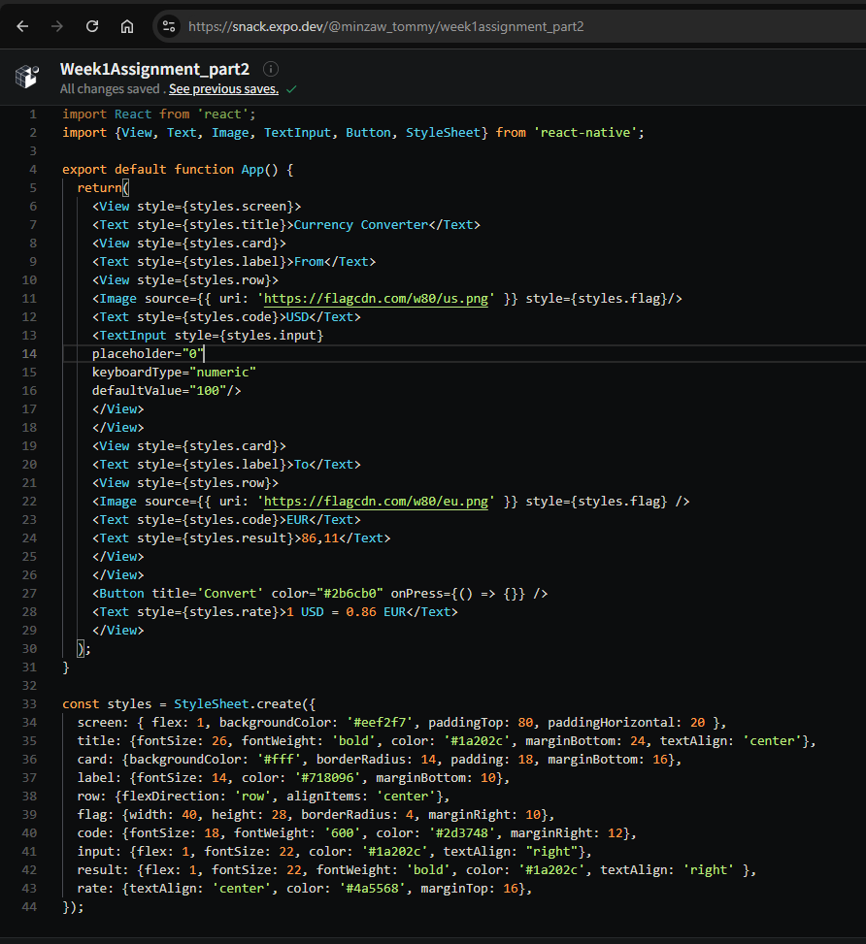
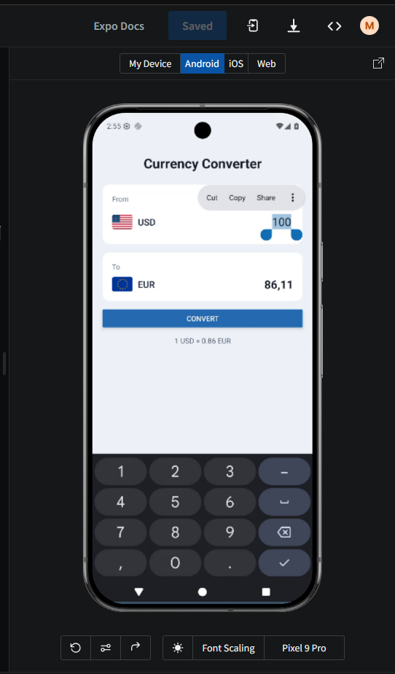
For the reflection, for each component I used other than View and Text, write one or two lines on what it does and where it’s used in real apps. I used three, so
- Image whish displays or icons, and used for logos, product photos, or flags in my converter app.
- TextInput: it lets the user type text, used in search bars, login forms and amount fields.
- Button which is a pressable control that runs an action and is used to submit forms, confirms or convert, for instance.

Part 3: Styling with StyleSheet
Apply your own styling using React Native's StyleSheet API.
Experiment with:
- Colors
- Layout
- Padding and margins
- Font styles
- Visual hierarchy
Reflection Questions
- How does styling in React Native differ from styling in traditional web development?
- What similarities exist between React Native styling and CSS?
- Which layout techniques did you use?

Part 3: Styling with StyleSheet
Answer:
- In web development, styles are written in separate CSS files and connected to HTML through class names, and the browser applies inheritance and the cascade automatically. in React Native there are no CSS files and no class names. Styles are written as JavaScript objects using StyleSheet.create, and each component is styled directly through its style prop like style={styles.card} in my app. The property names are also written in camelCase, such as backgroundColor and fontSize, instead of the hyphenated CSS versions background-color and font-size. There is no automatic inheritance between components, and sizes are plain numbers with no units like px or %.
- 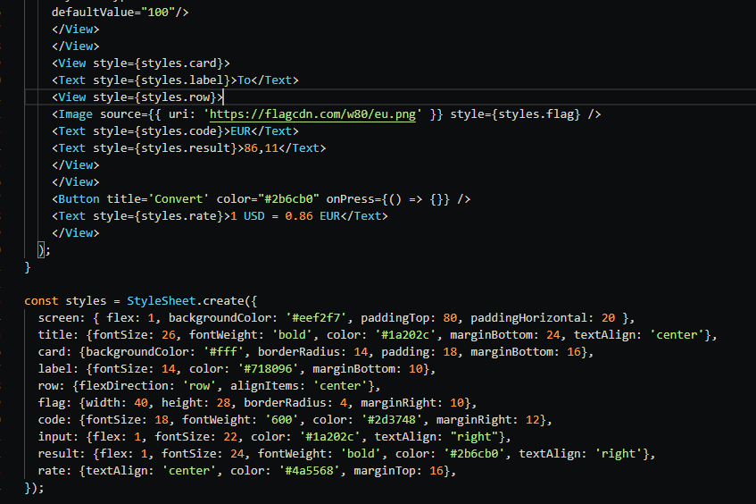
- Many properties have the same names and meanings as in CSS, for example, color, backgroundColor, padding, margin, fontSize, fontWeight, and borderRadius, which I used throughout my StyleSheet. Colors are written the same way using hex codes like #2b6cb0. Most importantly, React Native uses the Flexbox layout system, which also exits in modern CSS, so properties like flexDirection, alighItems, and justifyContent work in a familiar way. The general idea of keeping styling separate from the structure is also the same.
- 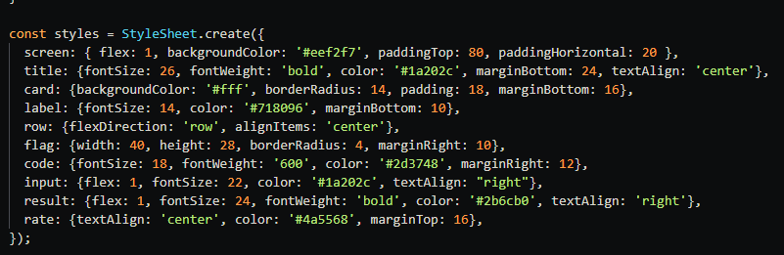
- I mainly used Flexbox. In each currency card I set flexDirection: ‘row’ so the flag, currency code, and amount sit next to each other in a line, and alignItems: ‘center’ to line them up vertically. I used flex: 1 on the screen so it fills the available space, and on the input and result so they stretch and push the amounts to the right. For spacing I used padding inside the cards and margin, such as marginBottom, to separate the cards. I also used textAlign: ‘right’ to align the numbers neatly.

Challenge Extension (Optional)
Test your application in different device previews available in Expo.
Try to ensure that:
- Content remains visible
- Elements do not overlap
- The UI remains visually balanced
Briefly describe any changes you made to improve responsiveness.
I previewed the app on the Android, and Web previews in Expo. On all three the content stayed visible, no elements overlapped and the layout remained balanced. Because I use flexbox with flex: 1 on the screen and paddingHorizontal on the sides, the cards automatically adjusted to different screen widths, so no major changes were needed.
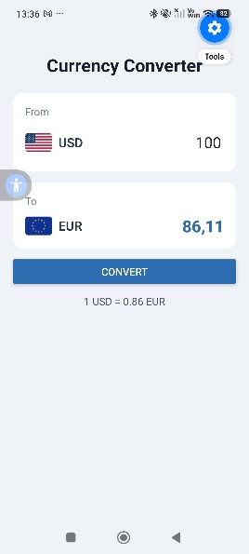
While testing on a narrow preview I noticed the row could feel tight, so I add flexWrap: ‘wrap’ to the row style so elements move to the next line instead of overlapping if space runs out. After this the UI stayed balanced on all previews.

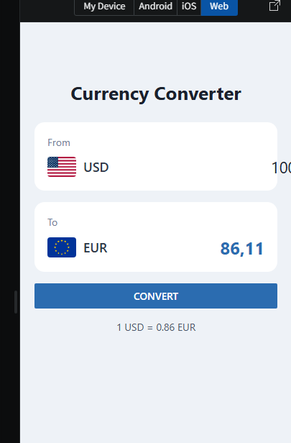

Using Artificial Intelligence Responsibly
Artificial intelligence tools are allowed in this course.
Examples include:
- ChatGPT
- GitHub Copilot
- Claude
- Gemini
- Microsoft Copilot
- Cursor AI
However, the goal of this first exercise is to build your own understanding of React Native fundamentals.
Recommended Approach
Before using AI:
- Read the relevant course materials.
- Explore the React Native documentation.
- Attempt the task independently.
After making your own attempt, feel free to use AI tools for:
- Clarifying concepts
- Understanding documentation
- Debugging problems
- Improving explanations
- Getting suggestions for UI design
Important
You are responsible for everything you submit.
You should be able to explain:
- Every major design decision
- Every React Native component used
- Any code included in your submission

AI Usage Report (Required)
Include the following section at the end of your submission.
AI Usage Report
Did you use AI tools?
- Yes
- No
Which tools did you use?
Yes, and it is claude.
Example:
- ChatGPT
- GitHub Copilot
How did you use them?
I first read the assignment and understood the task myself and then used claude to clarify React Native concepts, understand which core components to use, get suggestions for my UI design, and help debug an error in my code.
Example:
I used ChatGPT to understand the difference between FlatList and ScrollView and to get ideas for improving my UI design.
Approximately how much of your final work was directly AI-generated?
- 0%
- 1-25%
- 26-50%
- 51-75%
- 76-100%
Reflection
What was one thing that you learned yourself during this exercise that AI could not simply do for you?
It might be 26-50% of AI but not 50%. I just learned how React Native Flexbox layout actually behaves by adjusting the values myself and watching the live preview changes like seeing how flexDirection and flex: 1 affected the arrangement gave me an understanding that only came from trying it, not from being told the answer.
Submission
Submit:
- Written answers for Part 1
- React Native source code
- Screenshots of your UI
- AI Usage Report
Development Environment
You may use:
- Expo Snack
- Expo Go
- Local Expo installation (optional)
A local development environment is not required for this exercise.

Assessment (5 points)
Area | Points
Theory answers | 2
UI implementation | 2
Styling and presentation | 1

